Site Name and Address

Survey Type

Simply Ecology Limited

Ref: SE/QuoteNo/01
Month 2019

For

Client Address
(Shift enter to fill in)

CONTENTS PAGE
1.0 Introduction 1
1.1 Background Information 1
1.2 Aims 1
1.3 Site Description and Proposed Works 1
2.0 Survey Methodology 6
2.1 Desk Study 6
2.2 Extended Phase 1 Survey 6
2.3 Invasive Alien Plants 7
2.4 Bat Building Inspection Survey 7
2.5 Barn Owl Inspection Survey 7
2.6 Bat Activity Surveys 8
2.7 Bat Tree Survey 8
2.8 Personnel 9
2.9 Timing and Constraints 10
3.0 Desk Study results 12
3.1 Nature Conservation Sites 12
3.2 Priority Habitats 12
3.3 Protected and Noteworthy Species 13
3.4 Pre-existing data 15
4.0 Phase 1 survey results 17
4.1 Habitat Results 17
4.2 Invasive Alien Species 20
4.3 Tree Inspection 20
4.4 Breeding Birds 20
5.0 BUilding survey results 21
5.1 Site and Habitat Description 21
5.2 Main Building 21
5.3 Bat Tree Inspection 21
5.4 Other Protected and Noteworthy Species 22
6.0 CONCLUSIONS AND RECOMMENDATIONS 23
6.2 Bats 23
6.3 Barn Owl 24
6.4 Trees 24
6.5 Breeding Birds 25
7.0 references 26
ANNEX A: STATUTORY AND PLANNING CONTEXT 27
ANNEX B: IMPACT ASSESSMENT CRITERIA 30
ANNEX C: IMPACT RISK ZONES FOR SSSIs (2017) 32

PLANS PAGE
Plan 1: Existing and proposed site plan. 3
Plan 2: Existing and proposed site elevations. 4
Plan 3: Red line site boundary. 5
Plan 4: Priority habitats located within 1km of the site boundary. 13

Revision and Amendment Register
 | Name | Position
Author: | NAME | POSITION
Checked and Approved by: | Jason Reynolds MSc MCIEEM | Director
Version History
Version | Date | Modified by | Approved by | Comment/Reason(s)
1 | DATE | N/A | JR | First Issue
Disclaimer
This report has been prepared by Simply Ecology Limited with all reasonable skill, care and diligence, within the terms of the Contract with the Client. The actions of the surveyor on site and during the production of the report were undertaken in accordance with the Code of Professional Conduct for the Chartered Institute of Ecology and Environmental Management. (www.cieem.org.uk).
This report has been prepared by Simply Ecology Limited for the sole use of the client and in connection with the development project described – this report cannot be relied upon by any third party without express written consent by both Simply Ecology Limited and the client.
This is a technical report and does not represent legal advice/ opinion.
This report remains Simply Ecology Limited property and cannot be relied upon until full payment has been made.
Simply Ecology Limited retain the right to re-publish data obtained and submit those species records produced during all ecological studies to the local recording centre.
Copyright ©
This report is the copyright of Simply Ecology Limited. Any unauthorised reproduction or usage of material from this report is prohibited.
- Introduction
  - Background Information
    - In February 2019, Simply Ecology Limited was commissioned by Mr Peter McMullen to undertake an ecological survey of 11 The Spinney, Lancaster, LA1 4JQ (OS grid reference SD 48748 60275). See Plan 1 for site location and Plan 2 for site plan.
  - Aims
    - PHASE ONE SURVEY AIMS (remove this heading): The aims of this ecological assessment were to:
- To provide clear advice to the client, the Local Planning Authority and third parties, on the nature conservation value of the site and surrounding area.
- To confirm the presence or absence of protected species, such as badgers, bats, great crested newts, otter, etc) within the proposed development site.
- To enable the client to comply with legislation afforded to protected sites and species.
- To highlight the presence of any habitats or species of ecological importance, including Habitats and Species of Principal Importance (NERC Act, 2006).
- To identify any ecological constraints on future development.
- To establish the need for any further surveys and assessments.
- To make nature conservation recommendations.
    - BUILDING INSPECTION AIMS (remove this heading): The aims of this survey were to gather up-to-date information on the presence of bats at the site. This involved:
- Identifying potential structures of the buildings that could be used by bats.
- Identifying if there was any evidence of bats around the buildings.
- NIGHT TIME SURVEY ADDITION (remove this heading): Identifying whether bats were emerging from the buildings, and if so, to identify the number and species present.
- Providing an assessment of the likely importance of the site for bats and their conservation.
- Advising the client in relation to the proposed development and any impacts upon bats in order to ensure legislative compliance.
    - To achieve this, an ecological appraisal of the building and any protected species on the site was undertaken on 7th February 2019. A follow up night time bat survey was carried out on 26th July 2019. This submission presents the results of the surveys at the site.
  - Site Description and Proposed Works
    - The Site is located to the east of the village of Bilsborrow and approximately 6km from the northern limits of the city of Preston. The site is a 2.97 acre plot with residential dwelling, and accompanying barns and outhouses. The landscape surrounding the property is largely agricultural, with fields separated by hedgerows and given over variously to mixed arable and pasture.
    - The surveys described in this report were commissioned to inform a planning application for the demolition of the existing building and some of the outhouses and building of a new dwelling. Current status of planning permission (if applicable) application - if the proposal is for demolition only, of a structure supporting bat roost(s), are there plans to redevelop the site?
    - Is the application part of a larger development project? If so, how does this relate to the larger project?
    - Are there any past or future developments or projects (last 5 years) which are likely to have significantly impacted the population/habitat. Discuss with client and/or LPA; a brief summary is needed for licence application
- NB: Newt licence Method Statement include any projects within 100m of site boundary, and any further away that are likely to seriously impact on the population at the site. Include current projects, any from the last 5 years, and any planned to happen within the next 5 years.
    - Total size of the development (ha) and areas of the site with potential for bats (ha).
    - FOR BARN OWLS (remove this heading): Need proximity to major roads, land use and suitability of habitat within 1km (look at maps etc for suitable rough grassland likely to have voles in), condition and building use of current site.
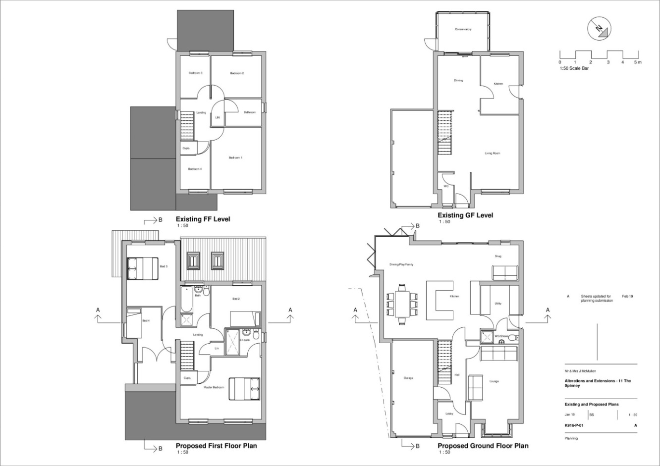
Plan 1: Existing and proposed site plan.

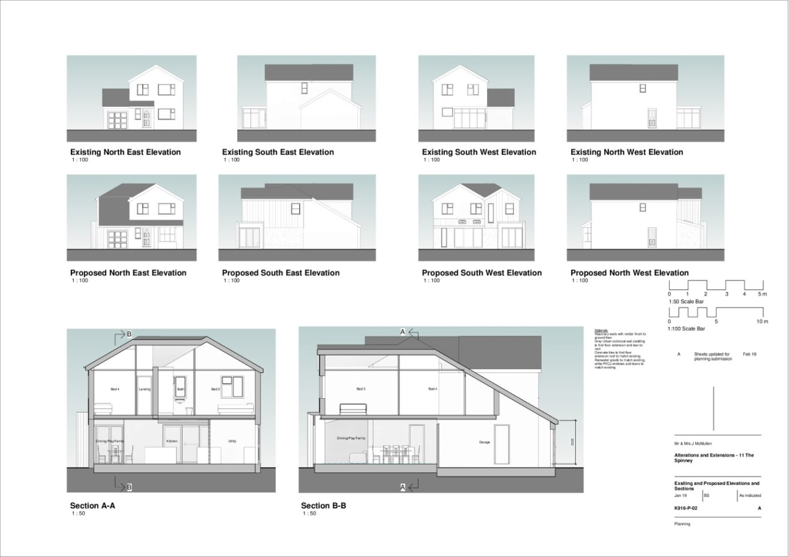
Plan 2: Existing and proposed site elevations.

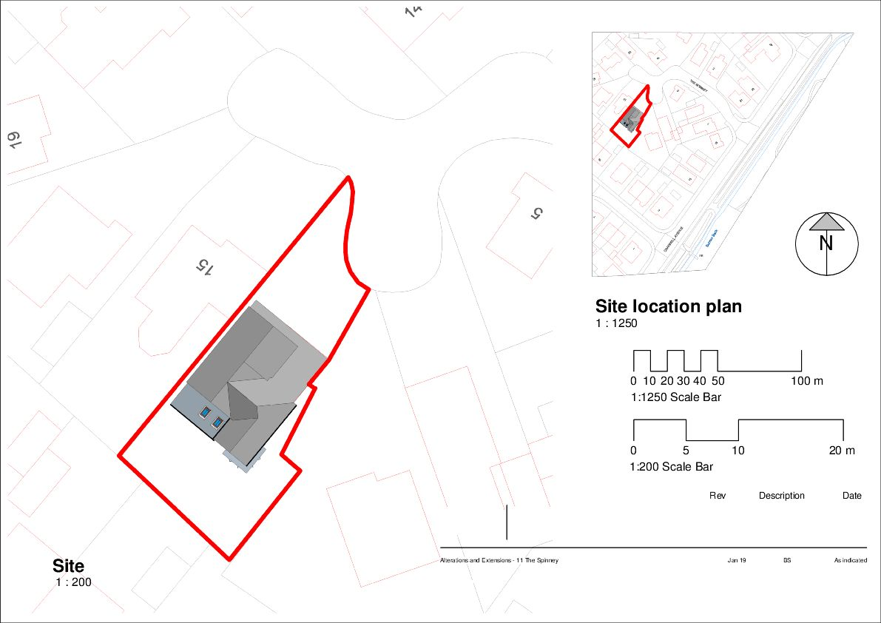
Plan 3: Red line site boundary.

- Survey Methodology
  - Desk Study
    - PAID FOR DATA SEARCH (remove this heading):
    - For the desk study, the application site and surrounding 1km was selected to search for any existing biological information. Consultation with commercially available datasets was undertaken to identify records of animals or plants within this search area. Lancashire Ecological Records Network (LERN) supplied the relevant documentation.
    - In addition, an online search of the Multi Agency Geographical Information Centre (www.magic.gov.uk) and Natural England’s Nature on the Map (www.natureonthemap.org.uk) was undertaken to identify the presence of nationally or internationally important sites receiving statutory protection. This included sites designated under the Wildlife and Countryside Act 1981 (as amended) and the Conservation of Habitats and Species Regulations 2010. This covers Sites of Special Scientific Interest (SSSI), Special Protection Areas (SPA) and Special Areas of Conservation (SAC) all of which have legal protection.
    - FREE DATA SEARCH (remove this heading):
    - An online search of the Multi Agency Geographical Information Centre (www.magic.gov.uk) was undertaken to identify the presence of nationally or internationally important sites receiving statutory protection within 1km of the application site. This search included sites designated under the Wildlife and Countryside Act 1981 (as amended) and The Conservation of Habitats and Species Regulations 2017. This covers Sites of Special Scientific Interest (SSSI), Special Protection Areas (SPA) and Special Areas of Conservation (SAC), all of which have legal protection.
    - No paid commercial desk study was required in this case due to the small scale of the development proposals. Impacts on wildlife and conservation sites were considered based on information gleaned from the Extended Phase One Habitats Survey.
  - Extended Phase 1 Survey
    - The Phase 1 habitat survey was undertaken by Kevin Heywood BSc (Hons) ACIEEM on 6th February 2019. The survey followed the Phase 1 habitat survey methodology (JNCC, 2010) which is a standard technique for recording and mapping habitats. During the Phase 1 survey the presence or potential for presence of protected species was recorded and assessed.
    - The survey involved walking the whole site, mapping and describing different habitats (for example: woodland, grassland, scrub). Evidence of fauna and faunal habitat is also recorded (for example droppings, tracks, or habitat such as ponds for breeding amphibians). The methods used for ecological survey are in accordance with those established and generally accepted methodologies for field survey, as published by the professional body, the Chartered Institute of Ecology and Environmental Management (CIEEM).
  - Invasive Alien Plants
    - During the Phase 1 habitat survey, observations of invasive alien plants listed under Schedule 9 of The Wildlife and Countryside Act 1981 (as amended) were made. The search included species such as Giant Hogweed (Heracleum mantegazzianum), Japanese knotweed (Fallopia japonica) and Himalayan balsam (Impatiens glandulifera).
  - Bat Building Inspection Survey
    - The building survey was undertaken in accordance with the standard methods described in the ‘Bat Worker’s Manual’ (JNCC 2004) and ‘Bat Surveys – Good Practice Guidelines’ (BCT 2016). The survey comprised the following elements:
- An inspection of the exterior of the buildings to look for obvious signs of bat activity (such as droppings on windowsills) and assessing the potential for entry/exit into the roof.
- An inspection of the interiors of all buildings, examining walls, the underside of roofs and within any loft spaces in the property to determine whether bats were present, to look for signs of bat activity (such as discarded prey items and droppings) and to assess suitability for bats. Lighting was provided by a Led Lenser XEO 19R (2,000lm) and/or Lezyne Mega Drive (1,200 lm).
- An assessment of the surrounding habitat quality for bats was carried out by walking the area on foot and later from reference to aerial images (Bing Maps). These searches were used to identify important land use and habitat features known to be favoured by bats.
    - Subsequent advice/action would depend on the findings of the building surveys. If potential was found then subsequent bat activity surveys would be required in accordance with standard methods described in the ‘Bat Worker’s Manual’ (JNCC 2004) and ‘Bat Surveys – Good Practice Guidelines’ (Bat Conservation Trust 2016).
  - Barn Owl Inspection Survey
    - The barn owl building survey was undertaken on the same day in accordance with the standard methods described in the ‘Barn Owl Conservation Handbook’ (Barn Owl Trust 2012). In accordance with best practice, the survey comprised the following elements:
- A desktop survey with local barn owl groups/enthusiasts, the County Bird Recorder, the British Trust for Ornithology (BTO) and the County Records Centre.
- An interview with local residents, workers or landowners with knowledge of the local area and target buildings in order to gather wider information about potential barn owls in the area.
- An external inspection of the buildings to look for potential access points into the property, perching places and signs of barn owl activity (such as characteristic ‘whitewash’ droppings).
- An internal inspection of the buildings to determine whether barn owls were present, to look for signs of activity (such as direct observation of birds; pellets, feathers, nest debris or whitewash droppings) and to assess potential suitability for barn owls. Lighting was provided by a Led Lenser XEO 19R (2,000lm) and/or Lezyne Mega Drive (1,200 lm) and ladders were used to inspect potential areas at height.
  - Bat Activity Surveys
    - An emergence (dusk) and re-entry (dawn) survey was undertaken in accordance with the standard methods described in the ‘Bat Worker’s Manual’ (JNCC 2004) and ‘Bat Surveys – Good Practice Guidelines’ (Bat Conservation Trust 2016). In accordance with best practice, the surveys comprised the following elements:
- Emergence Survey: One night-time visit was undertaken of the entire site to determine if bats were emerging from the buildings and to assess levels of bat activity.
- Re-Entry Survey: One survey was undertaken at dawn to determine the exact location of any roosts on site.
- During each survey, a surveyor was positioned to provide the best coverage of the buildings based upon the potential roost locations. The surveyor would be expected to hear and also see any bats emerging from the buildings. Activity was detected using Wildlife Acoustics EM Touch full spectrum bat detectors.
  - Bat Tree Survey
    - As part of the inspection, a visual survey of all trees was carried out using 10x42 binoculars. The survey was undertaken in accordance with the standard methods described in the ‘Bat Worker’s Manual’ (JNCC 2004) and ‘Bat Surveys – Good Practice Guidelines’ (BCT 2016). The survey comprised of identifying the following features:
- Woodpecker holes with small cracks/crevices
- Cracks/crevices, ivy cover and flaking bark
- Loose or flaking bark deadwood in canopy or stem low/no ivy cover
- Medium to dense ivy cover
- Deadwood in canopy or stem
- Snagged branches
- Hollow stems or limbs
- Hole in buttresses/hollow core
    - The following signs were searched for, as these would indicate bat presence:
- Staining around a hole, caused by natural oils in the bats’ fur.
- Stains beneath a hole, caused by bat urine.
- Scratch marks around a hole, caused by bat claws.
- Bat droppings beneath a hole.
- Audible squeaking from within a hole, especially on hot days or at dusk.
- Insects (especially flies) around a hole.
    - Once surveyed, each tree was categorised, using Bat Conservation Trust guidelines, according to its potential to support roosting bats into one of four categories:
1. Confirmed bat roost,
2a. High potential to support bats,
2b. Low/moderate potential to support bats, and
3. Negligible potential to support bats.
  - Personnel
    - All surveys were undertaken by (include class licence if applicable)…
    - Jason Reynolds MSc MCIEEM. Jason started Simply Ecology Limited in 2007. Jason is an experienced ecologist who has been continuously employed in the field of nature conservation since 1995 (24 years’ experience) and has a wealth of experience in both the statutory nature conservation agencies and private consultancy. During his career has worked in Conservation Officer roles for the Joint Nature Conservation Committee, English Nature, Environment Agency, Cumbria Wildlife Trust and Durham Wildlife Trust prior to setting up Simply Ecology ecological consultancy in 2007, where he is the Lead Ecologist. He has an MSc from The University of Aberdeen and his thesis investigated the relationship between habitat type and complexity and the foraging behaviour of Pipistrelle bats. Jason holds protected species survey licences for all British bats, white-clawed crayfish and great crested newts.
    - Kevin Heywood BSc (Hons) ACIEEM is an Ecologist with Simply Ecology Ltd. Kevin graduated with a first-class honours degree in Ecology from Lancaster University in 2015. In addition to this, he has acquired experience since 2012 working as an ecologist in a freelance capacity and since 2015 as a full-time employee for Simply Ecology Ltd. During this time, he has developed numerous field skills and carried out a wide range of botanical and protected species surveys. His expertise predominantly lies with habitat mapping and undertaking protected species surveys including: bats, great crested newts, badgers, otters and reptiles. Kevin holds a protected species licence for all British bats.
    - Samantha Gray BA (Hons) Grad CIEEM is a Business Ecologist working for Simply Ecology Limited. Since graduating with a Geography degree from Lancaster University in 2015, Samantha has gained over 3 years’ of experience in ecology. During this period she has completed an internship with Simply Ecology, where she developed her skills in botany, bat surveys and data analysis and also subsequently worked at RSPB Leighton Moss, carrying out habitat management and species monitoring work. In 2016 Samantha became a full-time employee with Simply Ecology as an Ecologist and Office Manager.
    - Chris Swindells BSc (Hons). Chris has over 15 years of experience in which time he has become a specialist in ornithology and rare plant ecology. Chris began as an amateur naturalist before studying Environmental science at the University of Bradford specialising in Ecology. He has worked for a number of ecological consultants as well as environmental research and advisory partnerships. His skill base covers a number of disciplines including NVC, protected species as well as impact assessment.
    - Philip Wright MSc. Philip obtained his first degree in Biology from the University of Bath and an MSc in Ecology and Conservation from Lancaster University. He is a member of the North Lancashire Bat Group and is in his second season of bat surveying. His wider experience includes conducting botanical surveying and habitat management work with the RSPB and with the Wildlife Trust for Lancashire, Manchester and North Merseyside.
    - Richard Lowe BSc (Hons) PGCE. Richard studied Environmental Management at The University of Central Lancashire and graduated in 1996. He has worked as an ecologist since that time in a variety of consultant roles, including as a Senior Ecologist at ERAP and latterly as a freelance contractor. Richard holds a great crested newt science and education licence. He has a broad range of experience of ecological survey and reporting knowledge, covering habitat mapping, protected species surveys and Environmental Impact Assessments. Richard is also an enthusiastic environmental educator, and regularly takes out school groups in Lancashire for the RSPB in his role as a Field Teacher.
    - Stewart Hirst. Stewart has an FdSc in Ecology and Conservation Management from Myerscough College. He is a member of the North Lancashire Bat Group and has three seasons of bat surveying. He has undertaken aquatic ecology and conservation work for Lancashire and Cumbria Rivers Trust since 2014 is experience includes conducting botanical surveying and habitat management work with the RSPB and with the Wildlife Trust for Lancashire, Manchester and North Merseyside.
  - Timing and Constraints
    - The building survey was undertaken on 19th July 2018. The timing of the building inspection to search for signs of bats posed no constraints as building inspections can be undertaken at any time of year. An assessment of the building’s potential to support bats can therefore be made according to evidence found, building condition, location and the experience of the surveyor. NB any other constraints e.g. refused access, safety issues preventing access
    - The night-time activity surveys of the property was/were carried on/between the 21st August and 11th September 2018. These surveys were commenced during the ideal survey period for bats and barn owls and the weather conditions were considered satisfactory to observe and record any activity of these species at the site (see Table 1). There were no significant obstructions to vision anywhere around the barn and it was possible to skyline the buildings.
    - The Phase 1 survey was undertaken on 1st March 2019. Whilst this is not the most optimal time to record flora, typically key indicator species can readily be identified using vegetative material and using dead plant matter. The timing posed no problems for the protected species assessment, and no constraints were encountered.
    - FOR BARN OWL SURVEYS (remove this heading): need to include anywhere that was not accessible/searched and why
Table 1: Weather conditions during the bat surveys.
Survey date | Temperature at the start of survey | Sunrise/ sunset time | Start and finish times | Weather
26/07/2019 | 15 ºC | 21:12 | 21:00-22:30 | 100% cloud cover, slight breeze after earlier rain.
- Desk Study results
  - Nature Conservation Sites
    - The search for conservation sites in the surrounding area included both nationally important sites, (Sites of Special Scientific Interest) and internationally important sites (Natura 2000 and Ramsar sites). The desk study revealed there were no statutory designated nature conservation sites on the site. However the Wyre Estuary SSSI, Morecambe Bay Ramsar and SAC sites were all located within 900m of the development boundary (see Error! Reference source not found.).
    - Given the proximity to the aforementioned SSSI, the site lies within surrounding Impact Risk Zones. The potential for impacts will require further consideration.
    - A total of six non-statutory Biological Heritage Sites (BHS) were identified within the local area, although none were present on site. The closest of which is…, which comprises…. This list of local Biological Heritage Sites was compiled from the Lancashire Environment Record Network (LERN). These are summarised in Table 2 and Error! Reference source not found., with further information provided in Appendix B.
Table 2: Local Biological Heritage sites.
Habitat Type | Site Name | Approximate Locations
Species-rich dune grassland | Fleetwood Cemetery | 400m northwest
Mosaic of coastal and dune grassland | Fleetwood Golf Course | 550m northwest
  - Priority Habitats
    - The desk study also revealed that a number of Priority Habitats were located within the surrounding 1km of the site. These consisted of… (see Table 3 and Plan 4).
Table 3: Priority Habitats within 1km of the site.
Habitat Type | Location | Relevant Legislation
Coastal and Floodplain Grazing Marsh | Outside of the site, approximately 188m southwest | NERC (2006)
Deciduous Woodland | Outside of the site, approximately 260m east | NERC (2006)
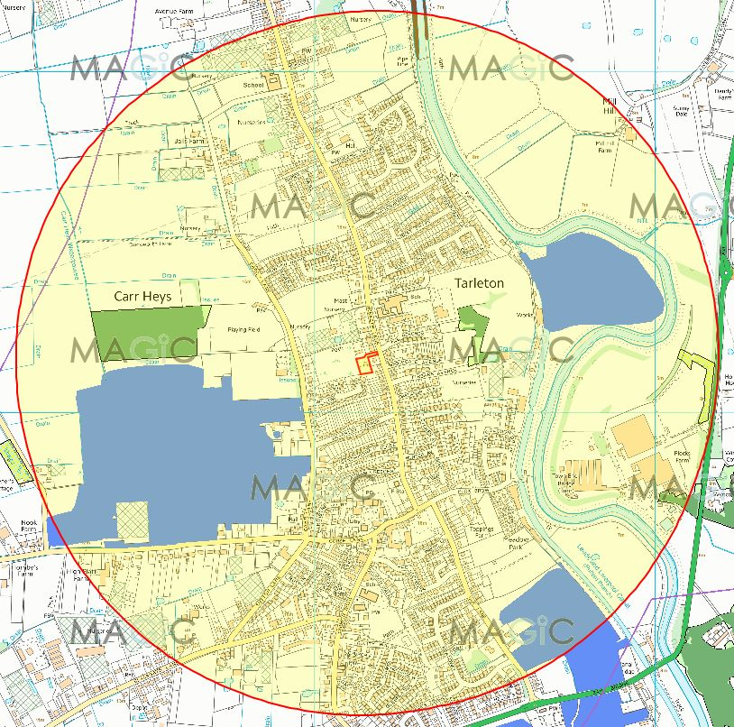
Plan 4: Priority habitats located within 1km of the site boundary.
  - Protected and Noteworthy Species
    - The Lancashire Environmental Record Network (LERN) was also contacted for a full data search of all records of protected species within a 2km area of the site. These are summarised in Table 4 below, along with an assessment of the potential for their presence on site. It is noted that the absence of records of other flora and fauna does not necessarily discount the possibility of protected species being on the site or in the vicinity.
    - The presence or absence of any protected species within the site was taken into account when carrying out the detailed site-specific searches as part of the extended Phase 1 survey. In addition, any habitat which had clear potential for any protected species was also taken into account when undertaking the site survey.
Table 4: Protected species identified within 2km of the site from Lancashire Environmental Records Network and judgement on the potential presence on site.
Latin Name | Common Name | Taxon Group | Legal Designation | Potential Presence
Alcedo atthis | Kingfisher | Bird | WCA 1 | No – lack of suitable habitat
Tyto alba | Barn owl | Bird | WCA 1; WCA 9 | No – lack of suitable habitat
Bufo bufo | Common toad | Amphibian | WCA 5 | Possible – some potentially suitable habitat
Lissotriton vulgaris | Smooth newt | Amphibian | WCA 5 | No – lack of suitable habitat
Rana temporaria | Common frog | Amphibian | WCA 5 | Possible – some potentially suitable habitat
Triturus cristatus | Great crested newt | Amphibian | HabsRegs2; WCA 5 | No – lack of suitable habitat
Zootoca vivipara | Common lizard | Reptile | WCA 5 | No – lack of suitable habitat
Arvicola amphibius | European water vole | Mammal | WCA 5 | No – lack of suitable habitat
Pipistrellus pipistrellus | Common pipistrelle | Mammal | WCA 5 | Possible – some potentially suitable habitat for foraging
Pipistrellus pygmaeus | Soprano pipistrelle | Mammal | WCA 5 | Possible – some potentially suitable habitat for foraging
Plecotus auritus | Brown long-eared bat | Mammal | WCA 5 | No – lack of suitable habitat
Cupido minimus | Small blue | Insect – butterfly | WCA 5 | No – lack of suitable habitat
Hyacinthoides non-scripta | Bluebell | Flowering plant | WCA 8 | Yes – suitable habitat on site
HabsRegs2 – The Conservation of Habitats and Species Regulations 2010 – Schedule 2
WCA 1 – Wildlife & Countryside Act 1981 (As Amended) – Schedule 1 – Birds that are protected
by special penalties
WCA 5 – Wildlife & Countryside Act 1981 (As Amended) – Schedule 5 – Animals that are protected
WCA 8 – Wildlife & Countryside Act 1981 (As Amended) – Schedule 8 – Plants that are protected
WCA 9 – Wildlife & Countryside Act 1981 (As Amended) – Schedule 9 – Animals to which Section 14 applies.
  - Pre-existing data
    - Whilst no specific records of roosts were verified at the desk study stage, Simply Ecology has carried out numerous bat surveys in the area. Consequently, all surveys were undertaken with the understanding that any of the 10 species encountered in Lancashire could be present. These include: common pipistrelle, soprano pipistrelle, nathusius’ pipistrelle, whiskered, brandt’s, natterer’s, daubenton’s, alcothoe, brown long-eared, noctule and leisler’s bats.

: QGIS PLAN HERE - Desk study results from LERN detailing the protected conservation sites and species within 2km, as well as invasive species.

- Phase 1 survey results
  - Habitat Results
    - The site covers approximately 0.2ha in area and comprises a single building surrounded by amenity grassland, hardstanding and scattered trees. A Phase 1 Habitat Plan is included in Error! Reference source not found. near the end of this section.
    - The following habitats were recorded at the site:
- Amenity grassland
- Gravel and Hardstanding
- Scattered trees

Amenity Grassland
    - The southern half of the site comprised of low cut amenity grassland, with a familiar species assemblage seen across typical regularly mown swards (see Plate 1). Grass species comprised of frequent smooth meadow-grass (Poa pratensis), Yorkshire fog (Holcus lanatus), common bent (Agrostis capillaris) and occassional perennial ryegrass (Lolium perenne). In addition, interspersed forbs included: ribwort plantain (Plantago lanceolata), creeping buttercup (Ranunculus repens), daisy (Bellis perennis), dandelion (Taraxacum), spear thistle (Cirsium vulgare) and turf moss (Rhytidiadelphus squarrosus).
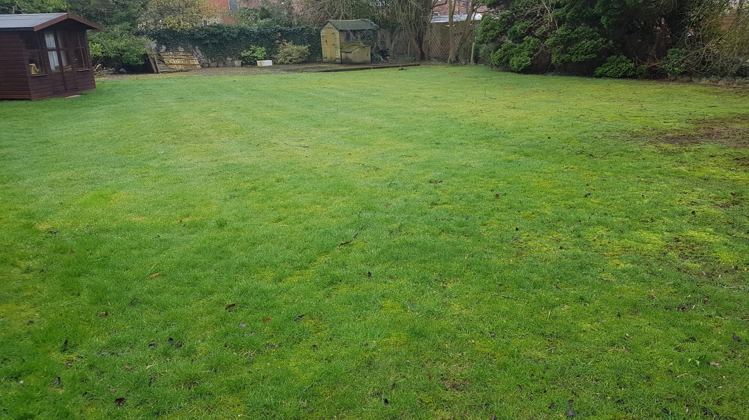
Plate 1:

Gravel and Hardstanding
    - The northern half of the site comprised of gravel with a hardstanding driveway, under regular use (see Plate 2). This contained little to no vegetation at all, with only a small assemblage of plants present around the borders of the site (see Error! Reference source not found.). This included locally frequent acrocarpus moss, thale cress (Arabidopsis thaliana) and broad-leaved willowherb (Epilobium montanum), with occasional petty spurge (Euphorbia peplus) and red deadnettle (Lamium purpureum).
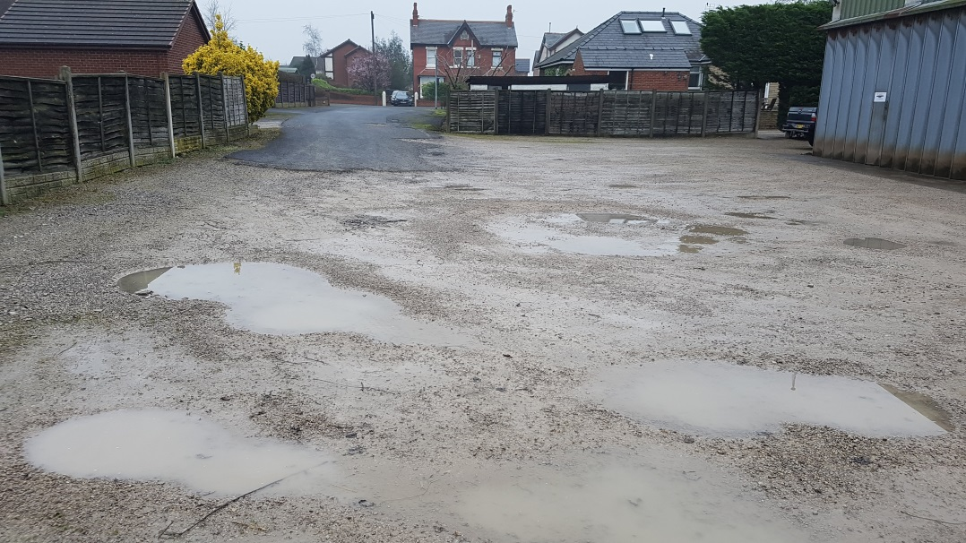
Plate 2:

: QGIS P1 PLAN HERE - Phase 1 survey map of the site.
  - Invasive Alien Species
    - No invasive species were identified on site.
  - Tree Inspection
    - The site contained only one semi-mature alder tree (Alnus glutinosa). This was thoroughly searched for any Potential Roost Features (PRFs), such as knot holes and cracks on limbs, during a ground-level tree inspection. However the inspection revealed that the tree trunk had a very small diameter and was smooth, offering no potential for roosting bats. It was therefore classed as a category 3 tree (negligible potential to support bats).
  - Breeding Birds
    - During the survey it was apparent that birds were utilising the site. Herring gulls (Larus argentatus) were seen to be gathering upon the amenity grassland area, whilst Blue tit (Cyanistes caeruleus) and Wren (Troglodytes troglodytes) were identified within the tall ruderal vegetation.
    - Whilst no active nests were discovered during the ground-level tree inspection, it is highly likely that breeding birds would utilise the trees on site during the nesting season (March to August inclusive).

- BUilding survey results
  - Site and Habitat Description
    - Brief description of the site, including total development size, areas of potential value to bats (ha) The site is a single storey, purpose-built school constructed in 1897. The school property is approx. 0.09ha and the footprint of the building, with potential value to bats, is approximately 0.035ha.
    - Brief description of the structures on site, differentiating between those surveyed and those not surveyed… The school building is a dressed and pointed stone structure with a roof of overlapping slate tiles. The entire building was subject to an internal and external survey for evidence of the presence of bats.
    - A description of the adjacent areas/offsite habitats, speci9fying any relevance to bats, including descriptions of habitats relevant to bat commuting/foraging behaviour Countryside surrounding the village is mostly open farmland, separated by hedgerow and trees representing good foraging habitat with suitable connectivity of linear commuting features.
  - Main Building

Internal
    - The outhouses of red brick with tiled roofs were generally in satisfactory condition although it was a little dilapidated in some areas (see Plate 3).

Plate 3:

External
    - Here…
    - In summary, the site contained numerous buildings which were assessed for signs of bat activity and potential roost features. Whilst several PRFs were identified in the various structures, their suitability for bats was considered to be rather low due to the condition of the buildings. Specifically, the wooden sheds, the garages and the coal shed had no potential for roosting because they offered no meaningful shelter from the elements or were prone to weather exposure. However, although no signs of bat activity were found, in accordance with Bat Conservation Trust Guidelines, the house and the red brick outhouses did offer some roosting potential (e.g. behind fascia boards on the house, under roof tiles on the outhouses) and consequently it was not possible to rule out the possibility that bats might use the structures for roosting.
  - Bat Tree Inspection
    - The site contained only one mature tree, a Norway maple (Acer platanoides) (See Error! Reference source not found.7). This was thoroughly searched for any Potential Roost Features (PRFs), such as knot holes and cracks on limbs, during a ground-level tree inspection. The tree had a heavy growth of ivy, and was considered to be a category 2b tree (Low/moderate potential to support bats) at best.
  - Other Protected and Noteworthy Species
    - Breeding birds
    - GCN
    - Owls
    - Invasive species

- CONCLUSIONS AND RECOMMENDATIONS
    - In June 2019, Simply Ecology Limited was commissioned by Cassidy & Ashton Ltd to undertake a preliminary bat roost assessment and eDNA sampling for great crested newts at Snapes Farm, Bilsborrow Lane, Bilsborrow, PR3 0RP. It is understood that the development will involve demolition of the main house and various other structures and conversion of the stone barn.
  - Bats
    - A bat scoping survey of the building was undertaken. It is understood that the work will involve replacement or repair of the external gable joists. The survey found that the building contained a number of potential bat roost features and easy access to the internal space. This included features such as gable vents, gaps in the gable verges and under roof tiles. In addition, evidence of bat activity in the form of droppings was confirmed during the survey. OR However, no evidence of bat activity was found.
    - The proposed development of the house/school/barn/building(s) could have the potential to affect any European protected species if found to be present. Whilst there was no evidence of bats using the buildings on site, there were numerous potential roost features, including gaps under fascia boards and under roof tiles at the rear of the house.
    - Given the potential roost features, signs of bats within the school, the high suitability of the proposed development site and the potential connectivity to the wider landscape, it is concluded that further survey information about the species of bat and their numbers will be required in order to gain Local Planning Authority permission and subsequent Licensing from Natural England prior to the conversion works going ahead.
    - Consequently, it is concluded that further bat survey will be required in order to gain an understanding of bat activity at the site and to establish whether any roosts are present.
- It is recommended that night-time bat surveys are conducted in order to establish the presence/absence of bats on the site, as well as species and numbers of individuals. Only then can the development be carried out in a way that the developers can be sure they are not negatively impacting on local bat populations. Reason: To carry out appropriate survey in accordance with the Bat Conservation Trust guidelines in order to deliver legal compliance. All UK bat species are protected by The Wildlife and Countryside Act (1981) (as amended) and the Conservation of Habitats and Species Regulations (2017).

    - Despite completing a thorough search of the building to identify Potential Roost Features and to search for signs of bat activity, no potential and no signs of bats were found. It was therefore concluded that there is no reasonably foreseeable likelihood that roosting bats are present.
- It is advised that all works can continue with no need for any supervision by the Appointed Ecologist. No Natural England licence is necessary in this instance as no impact upon any bat roost is predicted. This is due to the lack of any signs of current or historical use of the building by bats. Reason: This will deliver compliance with: Section 9 (1 & 4) of The Wildlife & Countryside Act 1981 (as amended), Part 3 (43; 1 & 2) of The Conservation of Habitats and Species Regulations 2017 and Section 15 of The National Planning Policy Framework (2018).
  - Barn Owl
4.2.1 The presence of evidence in the form of 26 barn owl pellets, ranging from 1 month to 12 months old, suggests that the site is used by barn owls. The surrounding landscape was considered suitable for barn owls and the barn clearly had some limited potential for barn owl activity. Any development of the site would lead to the loss of barn owl roosting potential. Therefore:
- It is recommended that the site is re-surveyed no more than 3 days immediately prior to development. This must be carried out to ensure that nesting is not taking place at the site during the development, particularly as Barn owls are known to nest throughout the year. Reason: This will ensure that no offences are committed under the Wildlife and Countryside Act 1981 (as amended by the CRoW Act 2000).
- It is recommended that no building or construction work should be carried out during the main breeding season (March to August inclusive). It is illegal to disturb breeding barn owls at, on or near a nest from the time the first egg is laid, to the time the last dependent young stops returning to the nest. Reason: This will ensure that no offences are committed under the Wildlife and Countryside Act 1981 (as amended by the CRoW Act 2000).
- It is recommended that temporary alternative provision for barn owls should be provided during the development period. Any planning consent should include a condition requiring that a nest box must be mounted in a nearby suitable building (or, failing this, a suitable tree) at least 30 days prior to the beginning of any construction work. Details of the box and the suitable alternative location are detailed in SECTION () below, in accordance with the guidance published by the Barn Owl Trust (with the support of Natural England) in Barn Owls and Rural Planning Applications “What needs to happen” A Guide for Planners. Reason: To ensure ongoing provision for roosting or nesting barn owl during the development works.
- It is recommended that permanent barn own provision should be incorporated into the new development. Any planning consent should include a condition requiring that development shall not commence until the Local Authority has given advance approval to a plan showing how permanent provision for barn owls will be incorporated into the development itself. Details of the location and measurements of the new permanent provision are detailed in SECTION () below, in accordance with the guidance published by the Barn Owl Trust (with the support of Natural England) in Barn Owls and Rural Planning Applications “What needs to happen” A Guide for Planners. Reason: This will deliver compliance with the NERC Act 2006 to restore and enhance a population or habitat for the purposes of conserving biodiversity.
  - Trees
    - The only mature, standard tree on site is the Norway maple adjacent to the house.
- It is recommended that retention of this tree should be attempted in order to retain the habitat value for wildlife and to ensure that the development of the site will have no detrimental impact upon the site’s overall biodiversity value. If the tree is to be felled it should first be subject to a high-level inspection for bats. It is noted from that no tree felling is proposed – therefore the development complies with this recommendation Reason: This will ensure compliance with the National Planning Policy Framework and the Local Authority’s statutory duty to conserve and enhance biodiversity under The Natural Environment and Rural Communities Act 2006 which is reflected in the Local Plan.
- It is recommended that, during construction, this if this tree is to be retained within the development should be subject to protection measures for the duration of the works. Fencing to protect the trees and root protection zones should be installed in accordance with BS5837:2012 ‘Guide for Trees in Relation to Construction Recommendations’. It will be particularly important to ensure that the mature trees on the boundary of the site are adequately protected from any excavations or accidental damage. Reason: This will ensure that the tree is not accidentally damaged or destroyed.
  - Breeding Birds
    - Although the site is highly unlikely to support a notable assemblage of birds in a local context due to its limited extent and nature of the habitats present, it is possible that the site is used by small numbers of breeding birds. In view of the protection afforded to all breeding birds, their nests and eggs, development works should proceed as follows:
- It is recommended that all demolition and site clearance work should be carried out outside of the bird breeding season (March to August inclusive). Where this is not possible, a suitably qualified ecologist should carry out a check to confirm the absence of nesting birds immediately prior to clearance works commencing. If a bird nest in current use is discovered, then an appropriate buffer zone around the nest should be created where clearance works can only continue after the nest is vacated. Reason: This will ensure that no offences are committed under The Wildlife and Countryside Act 1981 (as amended). The bird-nesting season is generally regarded to extend between March and August inclusive.
- references
BAT CONSERVATION TRUST (2016). Bat Surveys – Good Practice Guidelines. Bat Conservation Trust, London.
DEPARTMENT FOR COMMUNITIES AND LOCAL GOVERNMENT (2018) National Planning Policy Framework. HMSO. London
JOINT NATURE CONSERVATION COMMITTEE Mitchell-Jones, A.J. & McLeish, A.P. [Eds.] (2004) The Bat Workers Manual (3rd edition). Joint Nature Conservancy Council, Peterborough.
National Planning Policy Framework 2018:
https://assets.publishing.service.gov.uk/government/uploads/system/uploads/attachment_data/file/728643/Revised_NPPF_2018.pdf
Natural Environment and Rural Communities Act 2006:
http://www.opsi.gov.uk/acts/acts2006/ukpga_20060016_en_1
The Conservation of Habitats and Species Regulations 2017:
https://www.legislation.gov.uk/uksi/2017/1012/pdfs/uksi_20171012_en.pdf
Wildlife and Countryside Act 1981:
http://www.legislation.gov.uk/ukpga/1981/69/contents

ANNEX A: STATUTORY AND PLANNING CONTEXT
A.0.1 The client is advised that many species of British wildlife are legally protected. The following section provides a brief overview of the protection afforded to species commonly encountered during development. The Recommendations at the end of this report will advise as necessary, but it is also useful for the client to have an understanding of the legal protection as this helps to ensure that the law is complied with.

A.1 Badgers
A.1.1 Badgers are protected under Schedule 6 of the Wildlife and Countryside Act 1981 (as amended) (WCA), and the Protection of Badgers Act 1992. It is illegal to:
- Kill, injure, take, possess or cruelly ill-treat a badger or to attempt to do so;
- Interfere with a badger sett by damaging or destroying it;
- Obstruct access to or any entrance of a badger sett;
- Disturb a badger when it is occupying a sett
A.1.2 A badger sett is “any structure or place that displays signs indicating current use by a badger”. Natural England, the Government’s statutory nature conservation body, classifies a sett as active if it has been occupied within the last 12 months.
A.1.3 Operations that might cause disturbance of an active sett entrance can be carried out under licence from Natural England. If any badgers are found during the course of the survey, this will be highlighted in this report.

A.2 Birds
A.2.1 All wild birds are protected against killing or injury under The WCA 1981 (as amended). This protection extends to bird’s nests during the breeding season, which makes it an offence to damage or destroy nests or eggs. Birds that are listed on Schedule 1 of the Act receive additional protection against intentional or reckless disturbance during the breeding season. This makes it an offence to disturb these species at or near to their nesting site.

A.3 European Protected Species (includes bats, otter, hazel dormouse, great crested newts, and others)
A.3.1 The client is advised that all bats and great crested newts are European Protected Species (EPS). These EPS are protected under European legislation that is implemented in England via The Conservation of Habitats and Species Regulations 2010 (Regulation 41). A full list of EPS is provided in Schedule 2 of the Regulations. In addition, these EPS also receive the protection of the Wildlife and Countryside Act 1981 (as amended) in respect of Section 9 (4)(b & c) and (5).
A.3.2 If both national and international legislation are taken together, the legislative protection afforded to these species makes it an offence to:
- Intentionally/ deliberately kill, disturb, injure or capture them.
- Intentionally or recklessly damage, destroy or obstruct access to any breeding site or resting place.
- Possess or control any live or dead specimen or anything derived from a European Protected Species.
A.3.3 If an activity is likely to result in any of the above offences, derogation from the legal protection can be issued in the form of a European Protected Species licence issued by Natural England. Licences for development purposes are issued under The Conservation Of Habitats And Species Regulations (2010) and only allow what is permitted within the terms and conditions of the licence. If any EPS are found during the course of the survey, this will be highlighted in this report.

A.4 Protected Mammals and Reptiles (includes water vole, red squirrel, reptiles and others)
A.4.1 All native reptiles and a variety of British mammals also receive protection under The WCA 1981 (as amended). Schedule 5 of The WCA lists animals that are protected. The degree of protection varies. Water voles and red squirrel are examples of species with full protection. The Act makes it an offence to intentionally kill, injure, take, possess, or trade in any wild animal listed in Schedule 5, and prohibits interference with places used for shelter or protection, or intentionally disturbing animals occupying such places.
A.4.2 All native reptiles in the UK are protected. The commoner species such as grass snake, common lizard, slow worm and adder are protected only from unlawful killing and injuring. In practice this may require a reptile protection scheme before implementing a planning permission but no specific licence is required. Sand lizard and smooth snake listed as EPS (see A3.3 above).
A.4.4 If any protected species are found during the course of the survey, this will be highlighted in this report.

A.5 Non-native invasive species
A.5.1 A number of non-native plant species growing wild in the UK are listed on Schedule 9 of the WCA due to their invasive nature and the detrimental impact they can have on native habitats and wildlife. This legislation makes it an offence to plant or otherwise cause to grow in the wild any plant species which is included in Part II of Schedule 9.
A.5.2 This legislation should be considered during site clearance works which could lead to the spread of Schedule 9 listed plant species from the site if plant material is not properly handled and disposed of. Development proposals should also consider the removal of invasive species from areas of site that would otherwise remain unaffected by works in order to avoid the risk of these invasive plants spreading from the site in the future and enhance habitats within the site. This would in turn free up space for wildlife friendly planting, prioritising use of native species within planting schemes where appropriate.

A.6 Planning Considerations
A.6.1 When considering each planning application, the presence of protected species, such as those listed above, is a material consideration which must be fully considered by the Local Authority when granting planning permission. If a licence from Natural England is required, then prior to issuing any planning consent, the local planning authority will need to be satisfied that there is no reason why such a licence would not be issued. Therefore, in reaching the planning decision the local planning authority will need to have regard to the requirements of the Conservation of Habitats and Species Regulations 2010. The three licensing tests given in the Regulations must be considered. In summary, these are that:
1. The development is required for the purpose of:
- Preserving public health or public safety;
- For other imperative reasons of over-riding public interest, including those of a social or economic nature and beneficial consequences of primary importance for the environment;
- For preventing serious damage to property.
2. There is no satisfactory alternative.
3. The proposal will not be detrimental to the maintenance of the population of the species at a favourable conservation status.
A.6.2 All necessary information would need to be provided to the planning authority as part of the planning application in order to address the above tests.
A.6.3 The Natural Environment and Communities Act (NERC Act) 2006 extended the biodiversity duty set out in the Countryside and Rights of Way (CROW) Act to public bodies and statutory undertakers to ensure due regard to the conservation of biodiversity. The Duty is set out in Section 40 of the Act, and states that:
"Every public authority must, in exercising its functions, have regard, so far as is consistent with the proper exercise of those functions, to the purpose of conserving biodiversity"
A.6.4 The Duty applies to all local authorities, community, parish and town councils, police, fire and health authorities and utility companies. Section 41 (S41) of this Act (the ‘England Biodiversity List’) also requires the Secretary of State to publish a list of habitats and species that are of principal importance for the conservation of biodiversity in England. This list is used to guide decision-makers such as public bodies, including local and regional authorities, in implementing their duty under section 40(1) of the Act.
A.6.5 Also, Local Authorities must follow the National Planning Policy Framework (NPPF) which provides guidance on the interpretation of the law in relation to wildlife issues and development. For each development proposal considered by the Local Planning Authority the NPPF states that the authority must aim to conserve and enhance biodiversity. If significant harm resulting from a development cannot be avoided (through locating on an alternative site with less harmful impacts), adequately mitigated, or, as a last resort, compensated for, then planning permission should be refused.
UK Biodiversity Action Plan (UK BAP)
A.6.6 The UK BAP, which was first published in 1994, was the UK government response to the 1992 Convention on Biological Diversity. It sets priorities for nationally important ‘priority species’ and ‘priority habitats’. Each species and habitat action plan has costed actions and targets, and is used to inform the compilation of national lists such as the Section 41 List described above.

ANNEX B: IMPACT ASSESSMENT CRITERIA
Table 1: Valuing Ecological Features
Level of Value | Examples
International | An internationally designated site or candidate site (SPA, pSPA, SAC, cSAC, pSAC, Ramsar site, Biogenetic Reserve). A viable area of a habitat type listed in Annex I of the Habitats Directive, or smaller areas of such habitat which are essential to maintain the viability of a larger whole. Any regularly occurring population of an internationally important species, which is threatened or rare in the UK, i.e. it is a UK Red Data Book species or listed as occurring in 15 or fewer 10km squares in the UK (Categories 1 and 2 in the UK BAP) or of uncertain conservation status or of global conservation concern in the UK BAP. A regularly occurring, nationally significant population of any internationally important species.
National | A nationally designated site (SSSI, ASSI, NNR, Marine Nature Reserve) or a discrete area, which meets the published selection criteria for national designation. A viable area of a priority habitat identified in the UK BAP, or of smaller areas of such habitat which are essential to maintain the viability of a larger whole. Any regularly occurring population of a nationally important species which is threatened or rare in the region or county (see local BAP). A regularly occurring, regionally or county significant number of a nationally important species.
Regional | Viable areas of key habitat identified in the Regional BAP or smaller areas of such habitat which are essential to maintain the viability of a larger whole. Viable areas of key habitat identified as being of Regional value in the appropriate Natural Area profile. Any regularly occurring population of a nationally important species which is not threatened or rare in the region. Any regularly occurring, locally significant population of a species listed as being nationally scarce which occurs in 16-100 10km squares in the UK or in a Regional BAP or relevant Natural Area on account of its regional rarity or localisation. A regularly occurring, locally significant number of a regionally important species.
County | Semi-natural ancient woodland greater than 0.25ha. County/Metropolitan sites and other sites which the designating authority has determined meet the published ecological selection criteria for designation, including Local Nature Reserves selected on County/metropolitan ecological criteria. A viable area of habitat identified in the County BAP. A regularly occurring, locally significant number of a County/Metropolitan ‘red data book’ or BAP species, designated on account of its regional rarity or localisation. A regularly occurring, locally significant number of a County/Metropolitan important species.
District/Borough | Semi-natural ancient woodland smaller than 0.25ha. Areas of habitat identified in a sub- County (District/Borough) BAP or in the relevant Natural Area profile. Sites/features that are scarce within the District/Borough or which appreciably enrich the District/Borough habitat resource. A diverse and/or ecologically valuable hedgerow network. A population of a species that is listed in a District/Borough BAP, because of its rarity in the locality or in the relevant Natural Area profile because of its regional rarity or localisation. A regularly occurring, locally significant number of a District/Borough important species during a critical phase of its life cycle.
Site | Areas of habitat or populations/communities of species considered to appreciably enrich the habitat resource within the context of the parish or neighbourhood, e.g. species-rich hedgerows. NB: Where species or habitats occur in more than one category, the highest value is applicable.

Table 2: Impact Magnitude
Impact Magnitude | Examples
Major | Loss of over 50% of a site feature, habitat or population. Adverse change to all of a site feature, habitat or population. For benefits, an impact equivalent in nature conservation terms to gain of over 50% of a site feature, habitat or population.
Moderate | Loss affecting 20-50% of a site feature, habitat or population. Adverse change to over 50% of a site feature, habitat or population. For benefits, an impact equivalent in nature conservation terms to a gain of 20-50% of a site feature, habitat or population.
Slight | Loss affecting 5-19% of a site feature, habitat or population. Adverse change to 20-50% of a site feature, habitat or population. For benefits, an impact equivalent in nature conservation terms to a gain of 5-19% of a site feature, habitat or population.
Negligible | Loss affecting up to 5% of a site feature, habitat or population. Adverse change to less than 20% of a site feature, habitat or population. For benefits, an impact equivalent in nature conservation terms to a gain of up to 5% of a site feature, habitat or population.

ANNEX C: IMPACT RISK ZONES FOR SSSIs (2017)
